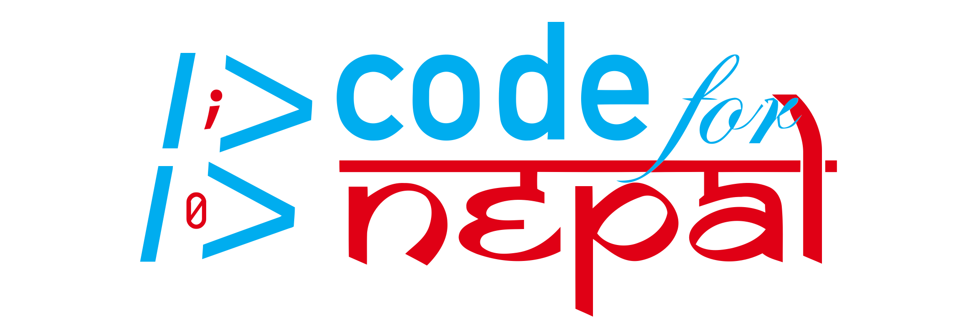

How to Use Microsoft OneNote

A User Based Documentation Guide

Prepared By Emma Chan for Code for Nepal



**Table of Contents**

1. Why OneNote?
2. Compatible Devices
3. Mobile vs. Browser Download
4. Creating a Microsoft Account
5. Easy as; One, Two, Three (Books, Sections, Pages)
6. Home
7. Insert
8. Draw
9. View
10. Class Notebook
11. Conclusion

**List of Figures**

* Figure 1: Devices that the Microsoft OneNote is Compatible With
* Figure 2: Microsoft OneNote can be accessed on a number of devices
* Figure 3: The Microsoft OneNote Icon (as seen on app stores for download)
* Figure 4: The browser *Free Download* button
* Figure 5: Microsoft Account Homepage
* Figure 6: Select “Create a Microsoft Account”
* Figure 7: What you need to create your Microsoft Office Account
* Figure 8: Microsoft OneNote helps you stay organized by separating your work into three categories: Notebooks (Broad Topics), Sections (General Ideas) and Pages (Specific Information)
* Figure 9: What tools can be accessed from the *Home* bar
* Figure 10: What tools can be accessed from the *Insert* bar
* Figure 11: What tools can be accessed from the *Draw* bar
* Figure 12: What tools can be accessed from the *View* bar
* Figure 13: What tools can be accessed from the *Class Notebook* bar

**Definitions**

Compatible: What the app works on.

Bar: The section on the top of the screen that shows you what tools you have access to.

**WHY ONENOTE?**

Despite being created by Microsoft, OneNote is compatible with a number of browsers and devices. Like Google Drive, it offers an offline option, but unlike Google Drive, OneNote does not require users to pre-download files and documents for offline access-all aspects of the app are automatically saved and uploaded whenever an internet connection is available. Unlike a majority of Microsoft Office (Word, Excel, PowerPoint) applications, you do not need to buy or license OneNote.

In addition to that automatic offline mode feature, OneNote’s mobile application does not require extensions or the download of additional applications. Google Drive requires you to subsequently have the Google Docs, Google Sheets and other Google Office applications in order to access those resources.

OneNote allows you to;

1. “Write” notes and organize them
2. Create tables
3. Attach files and links, insert images, meeting details, take screenshots and audio recordings.
4. Translate text into over 50 languages
5. Collaboration features designed specifically for classroom (features for students and teachers)
6. A lot more!

With the pandemic restricting access to in-person classes, technology and stable internet connections, Microsoft OneNote offers an easily accessible platform where resources can be saved, uploaded and shared amongst teammates (students, teachers).

**COMPATIBLE DEVICES**

Figure 1: Devices that the Microsoft OneNote is Compatible With

Any of the devices above can be used to access the Microsoft OneNote application. It can be downloaded on both mobile devices (tablets, phones) and computers/laptops as an application for offline use.

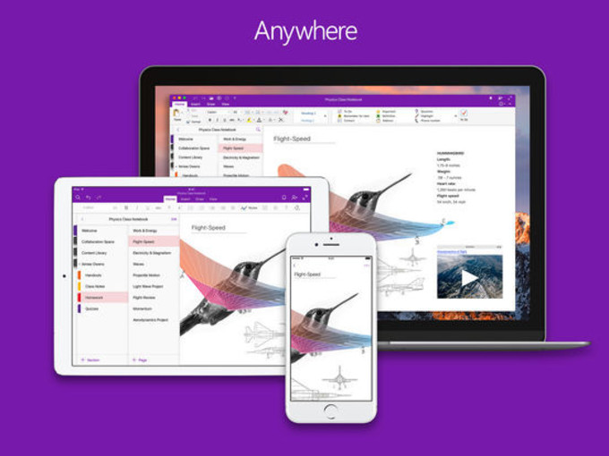

Figure 2: Microsoft OneNote can be accessed on a number of devices

**MOBILE VS. BROWSER DOWNLOAD**

*A stable internet connection is required to download the application

Mobile Download

To download OneNote on your mobile device (phone or tablet), simply search for the application (Microsoft OneNote) in your “App” Store.

* Apple Devices: App Store
* Microsoft Devices: Windows Apps
* Android Devices: Google Play Store

Figure 3: The Microsoft OneNote Icon (as seen on app stores for download)

Browser Download

Go to: [www.onenote.com](http://www.onenote.com)

Click on the “Free Download” Button

Figure 4: The browser *Free Download* button

The site will direct you the appropriate app store for your device, which instruct you through the remaining steps in the process.

**CREATING A MICROSOFT ACCOUNT**

In order to use Microsoft OneNote and synch your notes between devices, as well as share your work with other teammates, you will need to create a Microsoft account.

Go to: https://account.microsoft.com/account?lang=en-us

That will bring you to this screen, where you should select “Create a Microsoft account”.

Figure 5: Microsoft Account Homepage

Figure 6: Select “Create a Microsoft Account”

To create an account, you need a preexisting email address; Gmail, Hotmail and Yahoo email are all compatible with Microsoft. If you do not have an email address, you can also use a phone number to create your Microsoft account. You also have the option of creating an email account with Microsoft.

Figure 7: What you need to create your Microsoft Office Account

After entering a preexisting email or phone number, or creating a new one with Microsoft, you will be asked to create a password. An email or text will be sent to your phone or the email address you used to create the account, with a confirmation link. Once you click on that link, your account will have been set up, and you’re good to go!

**EASY AS ONE, TWO, THREE**

Microsoft OneNote helps you stay organized by three methods of categorization; Notebooks, Sections and Pages.

Notebooks are for broad topics or ideas. For example, the notebooks I currently have open are labeled: Emma’s Notebook, Fall 2020 and Careers.

Each notebook then has sections, which are smaller categories: for example, in my “Fall 2020” notebook, I have sections for each class that I’m in, as well as my extracurricular involvements.

The last category for organization on Microsoft OneNote is the pages. My pages tend to be class notes, study guides, reminders, schedules, random notes and more. Microsoft OneNote is a crucial part how I keep my life organized, and I think it’s a great tool for anyone who has been limited to internet access by this pandemic.

Notebooks Sections Pages

Figure 8: Microsoft OneNote helps you stay organized by separating your work into three categories: Notebooks (Broad Topics), Sections (General Ideas) and Pages (Specific Information)

**HOME**

The *Home* bar in Microsoft OneNote is how you control fonts (sizing, kind of font, text color), text orientation (left, middle, right), highlighting, lists (numbers, bullet points), heading formats and more!

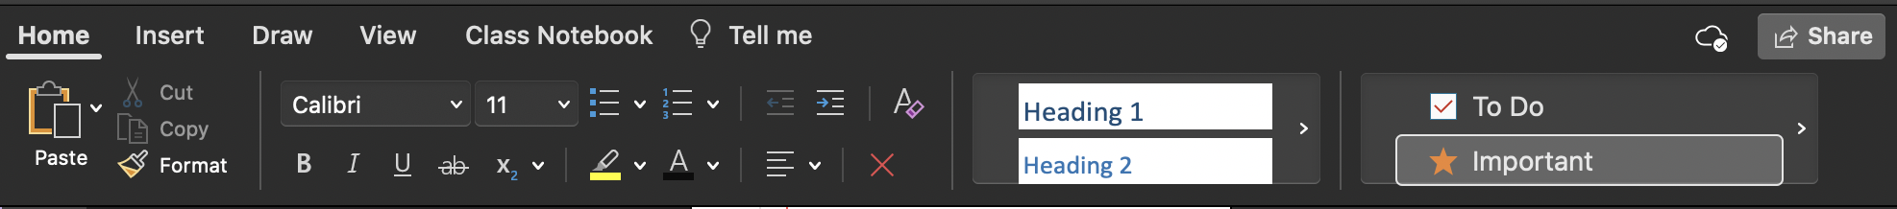

Figure 9: What tools can be accessed from the *Home* bar

**INSERT**

The *Insert* bar feature allows you to add charts, links, images/screenshots, equations, audio recordings and meeting details to your notes. You can also add icons and symbols using this feature.

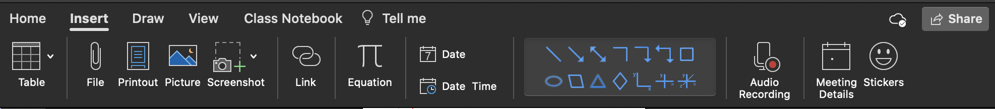

Figure 10: What tools can be accessed from the *Insert* bar

**DRAW**

The *Draw* feature allows you to control three methods of drawing; pen, marker and highlighter. You can control colors and the thickness (width) on each of the drawing tools. There is also an eraser tool that allows you to erase sections of drawings, and a lasso select tool to help highlight large sections of drawings, add charts, links, images/screenshots, equations, audio recordings and meeting details to your notes. You can also add icons and symbols using this feature.

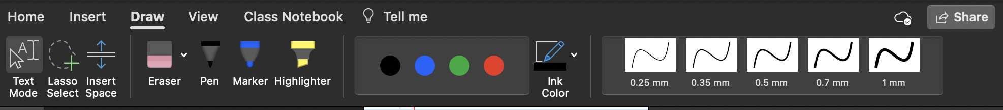

Figure 11: What tools can be accessed from the *Draw* bar

**VIEW**

The *View* feature allows you to control what you’re seeing on the screen, you can jump to a new window, view notes you recently deleted, zoom in and out of the current page, and even lock the section you’re in with a password.

Under the view section you can also change the color of the “paper” you’re working on, and change the style of the paper- blank, lined paper and even grids for drawing. You also have the option of hiding your page titles and the authors of the page.

OneNote also accounts for accessibility. Under the *View* tab, you can translate your text into over 50 languages, and even check the accessibility of your work (spelling errors, excessive whitespace and more).

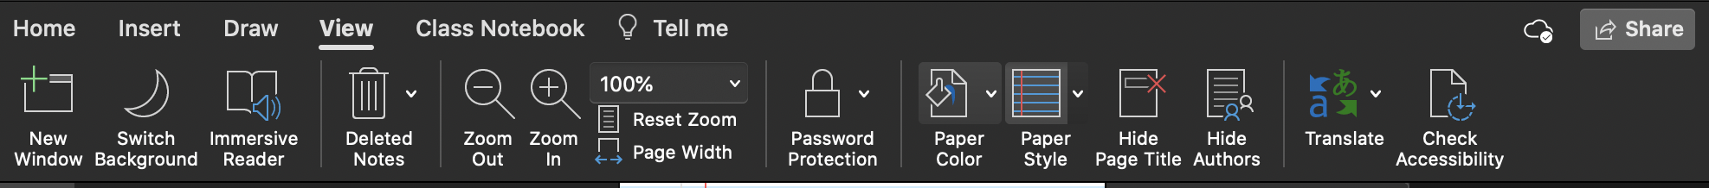

Figure 12: What tools can be accessed from the *View* bar

**CLASS NOTEBOOK**

The Class Notebook function is how you collaborate with your classmates, students or teammates. From this option, you can distribute pages and sections, review student work (for. Teachers). You can create a class notebook that can be accessed by authorized individuals and add/remove both students and teachers from this bar. You can also manage your notebooks and classes from this bar. Microsoft OneNote also offers Professional Development and Help/Feedback options under the Class Notebook tab. 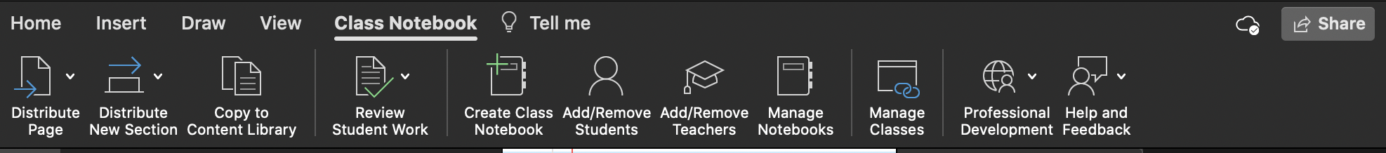

Figure 13: What tools can be accessed from the *Class Notebook* bar

**CONCLUSION**

I hope that this User Documentation Guide helps you get set up with Microsoft OneNote. This application had been helpful to me in times where access to technology was limited or internet connection wasn’t reliable. Given the current pandemic restrictions, I hope this helps you keep your schoolwork organized while staying connected to your fellow classmates/students/colleagues.